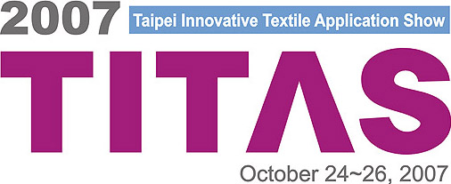
FAIR FACT
Taipei Innovative Textile Application Show
The Best Total Solution Sourcing Center in Asia.
F4+1: from Fibers to Fabrics for Fashion plus Functions
+ Full package services

- Fair Date： | October 24 ~ 26, 2007
- Opening Hours： | 9:30 a.m. to 5:30 p.m.
- Venue： | Taipei World Trade Center, Hall A, C & D  5 Hsinyi Road, Sec. 5, Taipei 110, Taiwan  Tel：+886-2-2725-1111
- Exhibition Space： | 17,000 sqm
- Exhibitors： | 350（anticipated）
- Visitors： | 19,000（anticipated）
- Exhibits Profile： | - Fibers / Yarns / Fabrics / Trimmings  - OEM/ODM Apparel & Accessories  - Textile Technology & Related Services  - Textile Machinery
- Participation Fee： | USD$ 2,500 / per 9 sqm – Shell scheme standard package  USD$ 2,200 / per 9 sqm – Raw space (min. 18 sqm.)
- Booth Package： | Standard booth includes partitions, carpeting, fascia, spotlights, racks/shelves, cabinet, table, chairs, waste basket, free catalogue entry
- Admission： | Trade visitors only by business cards or invitation
- Organizer & Contact： | Taiwan Textile Federation  Market Promotion Department  Mr. Ken Huang / Project Manager  Tel: (886)2-2341-7251 ext. 2331  Fax: (886)2-2391-7712, 2394-3245, 2392-9554  E-mail: titas@textiles.org.tw  Taiwan External Trade Development Council  5-7 Fl., 333 Keelung Rd., Section 1, Taipei 110, Taiwan  Tel: (886)2-2725-5200  Fax: (886)2-2757-6652
- Website： | www.titas.com.tw

紡拓會 台北市100愛國東路22號5樓 5F., TTF Building, 22 AiGuo East Road, Taipei 100, Taiwan
TAIWAN TEXTILE FEDERATION Tel: (886)2-2341-7251 Fax: (886)2-2394-3245 www.titas.com.tw, www.textiles.org.tw

